

**NSAT Anti-Bullying Policy**

|  |  |  |  |
| --- | --- | --- | --- |
| Author | S Orumlu | Source | Policy reviewed |
| Approved by |  | Status |  |
| Last review | June 2024 | Next review | June 2025 |

Details of Policy Updates

|  |  |
| --- | --- |
| Date | Details |
| 3/6/2024 | Updated references from KCSIE 2024  Added references from Preventing and Tackling Bullying DfE 2017 |
|  |  |
|  |  |
|  |  |
|  |  |

This Anti-bullying Policy complements the North Star Academy Trust shared values, NSTAR, Navigate Success Together with Ambition and Relevance.

It also complements and draws on the Safeguarding and Child Protection Policy, Behaviour and Relationships Policy, E-safety Policy and Child on Child Abuse Policy.

Bullying is an insidious form of behaviour which will not be tolerated in the North Star Academy Trust. Our Trust values focus on creating mutual respect and understanding of the needs of others amongst all who work and study here.

**Aims**

The unacceptable nature of bullying should be constantly reinforced as an integral part of the school’s stated aim of creating a caring and protective environment for all of its children and staff.

“Bullying, especially if left unaddressed, can have a devastating effect on individuals. It can be a barrier to their learning and have serious consequences for their mental health. Bullying which takes place at school does not only affect an individual during childhood but can have a lasting effect on their lives well into adulthood. By effectively preventing and tackling bullying, schools can help to create safe, disciplined environments where pupils are able to learn and fulfil their potential” (Preventing and Tackling Bullying’ DfE 2017). Therefore, this policy aims:

1. To ensure that all people (children and adults) in the school community are able to work in a safe and secure environment free from humiliation, harassment, oppression and abuse.

2. To clarify for all members of the school community that bullying is not acceptable and must be discouraged. Everyone must act in a positive way to ensure that bullying is challenged and reported

3. To ensure that all pupils, parents, staff, governors and all stakeholders are aware of this policy and know that appropriate action will be taken.

4**.** To recognise that bullying can take place off-site and that the school will endeavour to respond appropriately as if it had happened on site by involving external agencies.

The North Star Academy Trust is committed to combating bullying and this policy recognises the need to respect and support each individual in this area.

**Definition of Bullying**

“Bullying is behaviour by an individual or group, repeated over time, that intentionally hurts another individual or group either physically or emotionally. Bullying can take many forms, for instance: cyberbullying via on-line or text messages; social media or gaming, which can include the use of images and video. It is often motivated by prejudice against particular groups, for example on grounds of race, religion, gender, sexual orientation, special educational needs or disabilities, or because a child is adopted, in care or has caring responsibilities. It might be motivated by actual differences between children, or perceived differences.” (Preventing and Tackling Bullying DfE 2017)

Bullying can take many forms but may be:

* Physical: e.g. hitting, kicking, taking or hiding belongings.
* Verbal: e.g. name calling, teasing, insulting, racist remarks, and writing unkind notes.
* Emotional: e.g. spreading rumours, excluding from groups, tormenting, staring.
* A combination of the above: e.g. extortion (forcing someone to give up money or belongings) or intimidation (making someone frightened because of threats).

Any of these may also have contexts which discriminate in relation to race, sex, sexual orientation, special educational need, or disability.

**Possible Signs of Bullying**

Those pupils receiving bullyingmay show changes in behaviour such as becoming shy and nervous, feigning illness or clinging to adults. Their school work may deteriorate, they may lack concentration or attempt to not attend school.

All adults in the school have a responsibility to be aware of signs of distress in pupils as well as responding to direct/indirect disclosure. While the following types of behaviour may be symptomatic of other problems they may be the product of bullying.

**Child on Child Abuse**

Children and young people may be harmful to one another in a number of ways which would be classified as child-on-child abuse.

Abusive behaviour can happen to pupils in schools and settings and it is necessary to consider what abuse is and looks like, how it can be managed and what appropriate support and intervention can be put in place to meet the needs of the individual and what preventative strategies may be put in place to reduce further risk of harm.

Abuse is abuse and should never be tolerated or passed off as ‘banter’ or ‘part of growing up’. KCSIE 2024 describes child-on-childabuse as:

*“Child-on-child**abuse is most likely to include, but may not be limited to:*

* *bullying (including cyberbullying, prejudice-based and discriminatory bullying);*
* *physical abuse such as hitting, kicking, shaking, biting, hair pulling, or otherwise causing physical harm (this may include an online element which facilitates, threatens and/or encourages physical abuse);*
* *sexual violence such as rape, assault by penetration and sexual assault; (this may include an online element which facilitates, threatens and/or encourages sexual violence);*
* *sexual harassment such as sexual comments, remarks, jokes and online sexual harassment, which may be standalone or part of a broader pattern of abuse;*
* *causing someone to engage in sexual activity without consent, such as forcing someone to strip, touch themselves sexually, or to engage in sexual activity with a third party;*
* *consensual and non-consensual sharing of nude and semi-nude images and/or videos (also known as sexting or youth produced sexual imagery);*
* *upskirting, which typically involves taking a picture under a person’s clothing without their permission, with the intention of viewing their genitals or buttocks to obtain sexual gratification, or cause the victim humiliation, distress or alarm; and*
* *initiation/hazing type violence and rituals (this could include activities involving harassment, abuse or humiliation used as a way of initiating a person into a group and may also include an online element).*

Further guidance on child-on-child abuse and the Trust’s response to this can be found in the Child-on-ChildAbuse Policy.

**Encouragement to Tell**

It is important that we create an atmosphere in school where anyone who is receiving bullying behaviour, or others who know about it, feel that they will be listened to, and that action taken will be swift and sensitive to their needs. Disclosure can be direct and open or indirect and anonymous. Everyone must realise that not telling means that bullying is likely to continue.

**Reporting Bullying**

The North Star Academy Trust believes children and young people should have the right to feel safe, secure and valued, and that creating a safe environment and dealing with bullying is our shared responsibility. There are different ways of reporting bullying behaviour at school:

1. bullying behaviour report forms to be filled by students experiencing bullying or witnessing bullying (in writing, in pictures or with the support of an adult)
2. anonymous bullying behaviour report slips
3. texting/calling the North Star Academy Safeguarding mobile number- 07785 696238
4. emailing North Star Academy Safeguarding email address - [safeguarding@northstar-academy.co.uk](mailto:safeguarding@northstar-academy.co.uk)
5. contacting key adults at school
6. ‘Whisper’ online reporting tool

Staff should be aware that even if there are no reported cases of child-on-child abuse and bullying, such abuse may still be taking place and is simply not being reported.

**Procedures**

The exact course of action will vary with each situation, within the appendix of this policy there are stepped approaches and guidelines for reporting and challenging bullying behaviour, but the main objectives should be that bullying incidents are brought into the open, discussed and strategies agreed to help resolve the problem. It is always important to make clear that:

* the bullying behaviour is unacceptable, and the bullying must stop.
* everything that happens is carefully recorded.
* the application of sanctions will depend on the individual circumstances of each incident.
* the tutor team are a key part of the response to bullying.
* revenge is not appropriate for the student receiving bullying behaviour.
* the school will work with the parents of both the student receiving bullying behaviourand the student displaying bullying behaviour.
* support will be available for the student receiving bullying behaviour.
* support will be available for the student displaying bullying behaviour to help them understand and modify their behaviour.

The stepped approach for the bullying behaviour will be actioned immediately and treated on a rolling basis despite the term ending.

**The School Curriculum**

The unacceptable nature of bullying should be reinforced through the formal channels of assemblies, tutor time, the PSHE Curriculum and the wider curriculum. Individual members of staff are expected to respond to all instances of bullying. The exact course of action will vary with each situation, but the main objective should be that bullying incidents are brought into the open, discussed and strategies agreed to help resolve the problem.

The School curriculum will be used to:

1. raise awareness about bullying behaviour and about the school’s anti-bullying policy.

2. challenge attitudes about bullying behaviour, increase understanding and help build an anti-bullying ethos in the school.

3. encourage the mutual respect and tolerance in line with our School Values, NSAT.

**Responses to Bullying**

**Response by all School Staff**

* Intervention following observation of signs of bullying or following disclosure
* Receiving, responding, taking seriously and acting upon the information which is disclosed
* Recording and reporting (in writing using the internal referral system outlined in appendix A) any incident which is observed or disclosed
* Seeking support quickly from any member of SLT if very serious bullying (e.g. extortion or violent assault) is observed, suspected, or disclosed

**Anti-Bullying Ambassadors**

The Trust has a team of Anti-Bullying Ambassadors who have received training from the Diana Award ambassador training on peer-mentoring and dealing with incidents of bullying through an escalated response. They are a key part of the Trust’s response to incidents of bullying. They assist in developing staff training in the different areas of bullying, supporting peers and running whole school assemblies on bullying.

**Advice to Pupils**

Pupils should:

* remember that all pupils have a right not to be bullied.
* not feel ashamed if it happens to them.
* report bullying straight away, watching and doing nothing may suggest support for the person displaying bullying behaviour.
* tell someone they trust straight away.
* ask parents/family or teachers for advice and help. If they are too scared to tell an adult on their own, they should ask a friend to go with them.

**Advice to Parents**

Parents should:

* watch for early signs of bullying.
* listen and take seriously comments which your child may make to you about bullying.
* reassure your child that they are doing the right thing to tell you about the bullying.
* contact the school immediately.
* encourage your child to talk to someone they trust at school.

**Monitoring and Evaluation**

This policy and accompanying procedures will be monitored and the effectiveness will be evaluated in the light of:

* number of reported pupils receiving bullying behaviour.
* number of reported pupils displaying bullying behaviour.
* pupil’s willingness to report incidents.
* staff vigilance and response to bullying behaviour.
* numbers of pupils and parents feeling secure about the school’s response to bullying.

The Senior Member of Staff with responsibility for this policy area is the Designated Safeguarding Lead. The Anti-Bullying Staff Leads are responsible for ensuring that this policy is followed.

Appendix A – Staff actions for reporting bullying behaviour



**Staff Guidance for Reporting Bullying**

* Use CPOMS reporting system for all incidents of bullying behaviour
* Fill in bullying behaviour report form with child and upload this to CPOMS log where necessary
* Follow stepped approach to managing bullying behaviour flow chart
* Speak with Anti-Bullying Staff Lead where necessary



Appendix B – Stepped approach to bullying

Stepped Approach to Bullying

when there is a confirmed incidentof bullying using the DfE definition for bullying

*Additional support provided for students receiving and displaying bullying behaviour; depending on the needs of the students.



Stepped Approach to Bullying

when there is a confirmed incidentof bullying using the DfE definition for bullying

.

*Additional support provided for students receiving and displaying bullying behaviour; depending on the needs of the students.



Appendix C – Anti-bullying ambassador contract

Anti-Bullying Ambassador Contract

As an Anti-Bullying Team member:

* I will treat everyone in my school community with respect and dignity.
* I will act to ensure that everyone in my school community is included.
* I will help to ensure that everyone in my school community is treated fairly, regardless of their gender, identity, race, or beliefs.
* If I witness bullying behaviour, I will not be a bystander.
* I will speak out and report it to an adult.
* I understand the school’s anti-bullying policy and procedures.
* I will always help others when they are upset.
* I will listen to those who are receiving bullying behaviour.
* I will show kind behaviour to others.
* I will set a good example to others.

Signed by all members of the Anti-Bullying Team:



Appendix D – Bullying Behaviour report forms

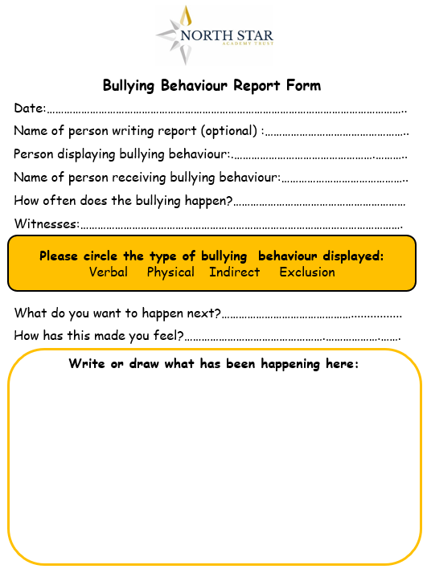

Appendix E – Bullying Behaviour reflection form

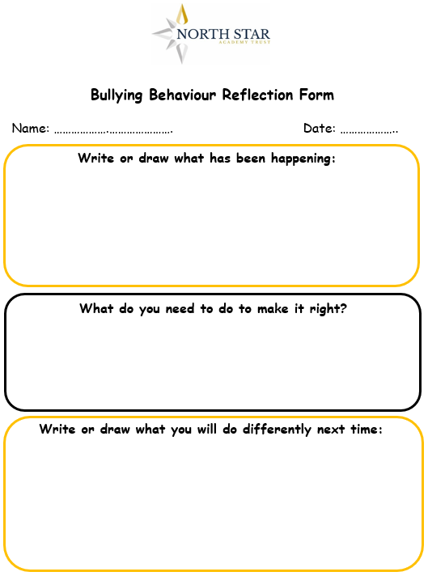

**What do the adults and children do to stop bullying?**

* Adults listen to us and believe
* We have an anti-bullying team and trained anti-bullying ambassadors
* We have lessons on anti-bullying
* School Council work to address any issues
* Staff monitor break times to keep us safe

Appendix F – Child Friendly Anti-bullying policy

